

**Reka Bentuk Antara Muka Berasaskan Web**

**(CSF3133)**

**LAB REPORT 1**

NAME: CHIA FU YAN

MATRIC: S75039

DATE: 22/10/2024

GROUP: K4

PROGRAM: Computer Science (Software Engineering)

**Activity 1.4 Structure of an HTML Document**



**1.5 Basic HTML Tags**

**Activity 1.5.1 Headings**

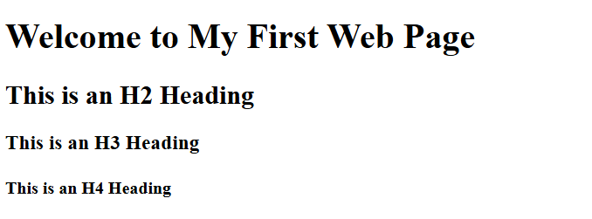

**Activity 1.5.2 Paragraphs and Text Formatting**

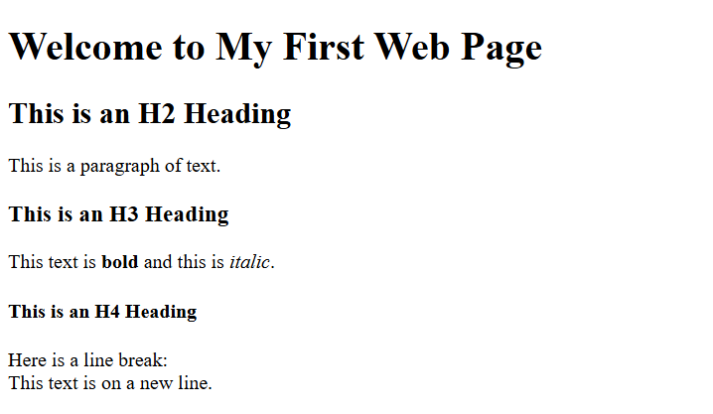

**Activity 1.5.3 List (Ordered and Unordered)**

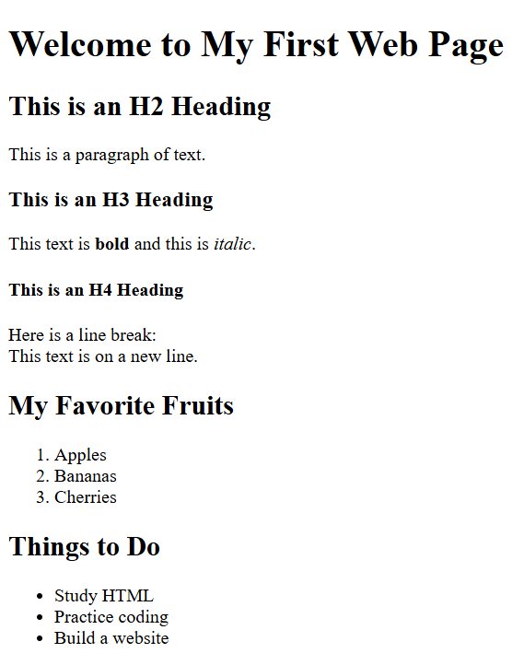

**1.6 Links and Image**

**Activity 1.6.1 Add a Hyperlink**



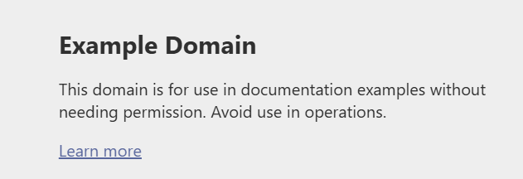

**Activity 1.6.2 Insert an Image**



**Activity 1.6.3 Commenting in HTML**



**1.7 Lab Exercise 1**

**Source code**

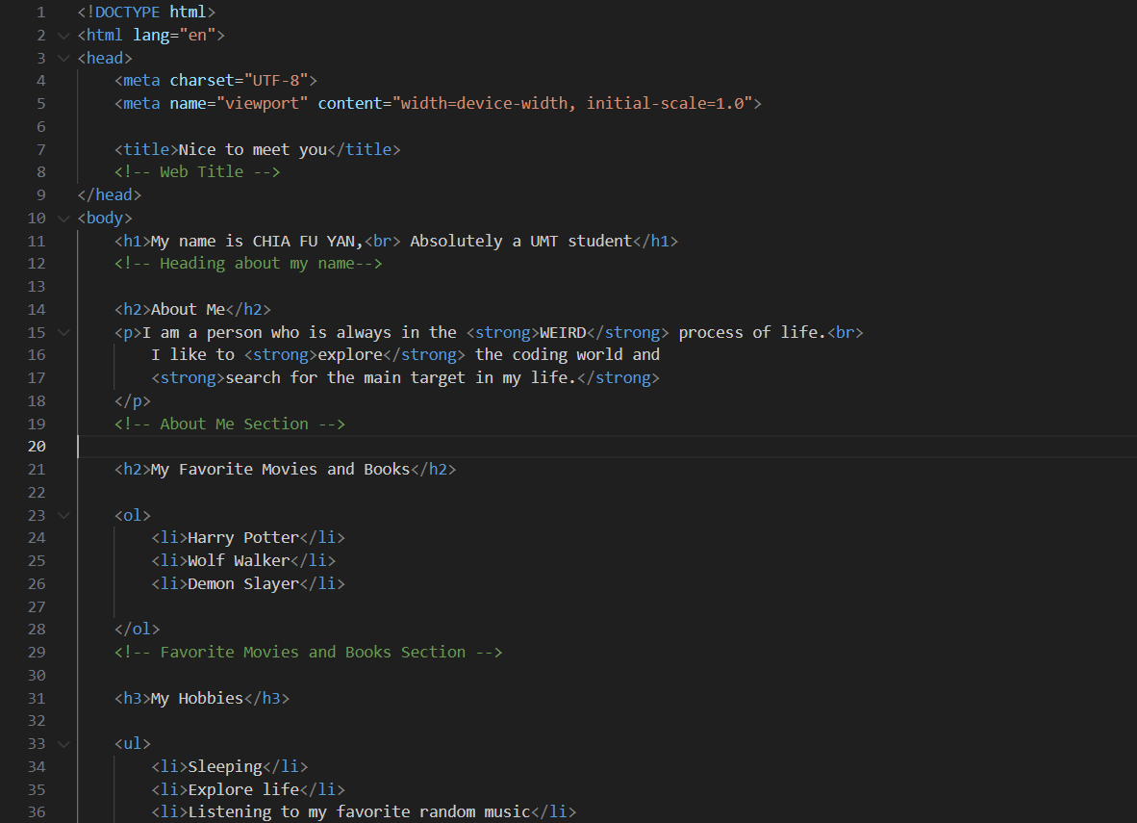

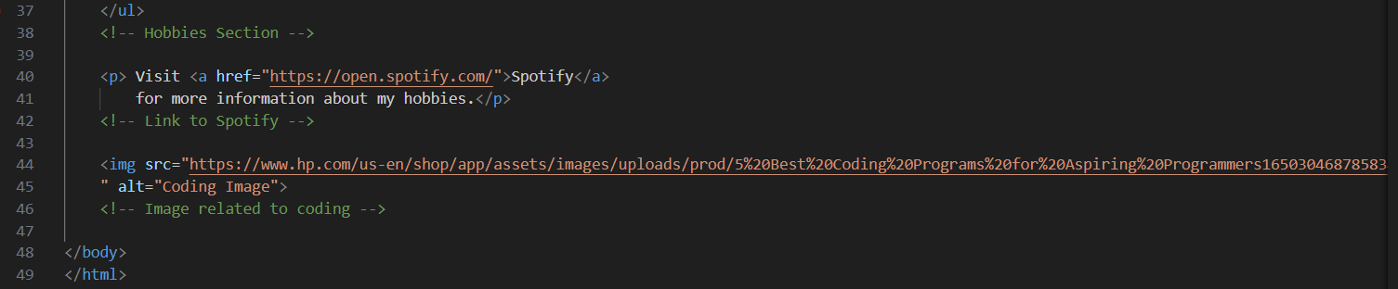

**Output**



